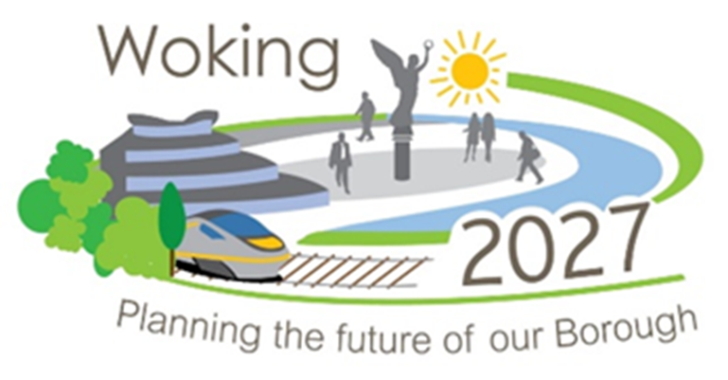

**Woking Borough Council Community Infrastructure Levy (CIL)**

# **Application form for CIL money to deliver local community infrastructure projects**

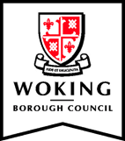

**Planning Policy team**

**Woking Borough Council**

**Civic Offices**

**Gloucester Square**

**Woking**

**Surrey**

**GU21 6YL**

**Telephone: 01483 743 871**

**Email:** [**planning.policy@woking.gov.uk**](mailto:planning.policy@woking.gov.uk)

## Introduction

Woking Borough Council adopted its Community Infrastructure Levy (CIL) Charging Schedule on 24 October 2014 to take effect from 1 April 2015. The Community Infrastructure Levy Regulations 2010 (as amended) imposes a duty on Woking Borough Council as a CIL Charging Authority to pass on a proportion of its CIL income to local communities where the chargeable development takes place.

Where there is an adopted Neighbourhood Development Plan in place for the area, the Neighbourhood Area gets 25% of the CIL income. Where there is no Neighbourhood Development Plan in place, the local community gets 15%. Where there is no designated Neighbourhood Area, it is proposed that the Ward boundary will be the basis for earmarking the CIL income for the local community.

The CIL Regulations prescribe what CIL income earmarked for local community projects should broadly be used on. The money must be used to support the provision, improvement, replacement, operation or maintenance of infrastructure, or anything else that is concerned with addressing the demands that development places on the area.

The Joint Committee at its meeting on 13 March 2019 agreed the arrangement for local communities to identify local community infrastructure projects that CIL money could be used and how Ward Councillors could make a request to the Council to secure CIL money to enable the delivery of the projects. This arrangement was reviewed by the Joint Committee at its meeting on 11 November 2020. The arrangement sets out key requirements that have to be met for an application to the Joint Committee to secure CIL money to be successful.

In December 2022 the Council agreed updated partnership arrangements for local communities to take forward community projects delivered with CIL money. This ensures arrangements are in place to deliver the actions of the Joint Committee, which has been disestablished. [At Council on 28 March 2024](https://moderngov.woking.gov.uk/ieListDocuments.aspx?CId=135&MID=1933#AI26215), it was agreed that the Neighbourhood CIL Task Group be disbanded and ‘authority be delegated to the Strategic Director for Place, in consultation with the Portfolio Holder for Planning, to determine any applications for Community Infrastructure Levy funding below £10,000’ and CIL Neighbourhood funds of a value over £10,000 to be approved by the Executive. A flowchart summarising the process for securing CIL money for community projects is available at [How we spend the income from the CIL levy | Woking Borough Council.](https://www.woking.gov.uk/planning-and-building-control/planning/planning-policies-and-guidance/how-we-spend-income-cil-levy)

This application form is intended to guide Councillors to provide the necessary information that will enable the CIL Task Group or Executive to determine applications for CIL funds.

For further information, clarification or guidance please contact the Planning Policy Team on 01483 743 871 or email: [planning.policy@woking.gov.uk](mailto:planning.policy@woking.gov.uk)

Please use this email address to submit your completed application form, along with the supporting information and evidence highlighted in the Application Checklist at the end of this form.

## **Application form**

|  |  |
| --- | --- |
| **Question** | **Response** |
| 1. Name of Ward or Neighbourhood Area |  |
| 2. Name of councillor submitting the application (or anyone with delegated authority to submit the application on behalf of councillors) |  |
| 3. Preferred contact details of councillor submitting the application (phone number or email or address) |  |
| Name of Project Manager who will be responsible for the proper implementation of the project and for all associated cost/financial processes. |  |
| 4. Name of project/infrastructure that CIL money will deliver |  |
| 5. Location of the project such as address, Location Plan. |  |
| 6. A brief description of the project and what it seeks to achieve |  |
| 7. What is the estimated total cost of the project and how much CIL money is requested? Have you taken into account the cost of managing the delivery of the project?  Please provide quotes for the work/project. |  |
| 8. Would there be additional sources of funding necessary and available to deliver the project? If yes, provide details. |  |
| 9. A brief statement of why CIL funding is being sought? |  |
| 10. How would the project help address the demands or impacts of development in the area. |  |
| 11. Is there evidence of broad community support for the project? Please provide the evidence. |  |
| 12. What is the indicative timescales for the delivery of the project |  |
| 13. Would there be associated revenue spend (such as day-to-day running costs, maintenance) for the project? How would this be met? |  |
| 14. Would you need planning permission to carry out the works? Officers can provide advice. |  |
| 15. Will the project affect the public highway? If yes, have you had an early consultation with Surrey County Council? An early consultation with the County Council will be helpful. |  |
| 16. When to submit an application? | It is recommended to seek Pre-application advice from the Policy Team before an application is submitted to ensure it meets the requirements. For all applications under £10,000 please speak to the Planning Policy Team to confirm times. For applications for over £10,000 applications are decided at Executive. Please refer to [Browse meetings - Executive (woking.gov.uk)](https://moderngov.woking.gov.uk/ieListMeetings.aspx?CId=165&Year=0) for dates and speak to the Planning Policy team as soon as possible to confirm lead in times for these larger applications, which as a guide will need to be submitted a minimum of 8 to 9 weeks prior to an Executive meeting. |

**CIL Funding Application Form requirements – application checklist**

* Have you read the CIL Flowchart on arrangement to use CIL money for local community projects? This can be found at [CIL flowchart.docx (live.com)](https://view.officeapps.live.com/op/view.aspx?src=https%3A%2F%2Fwww.woking.gov.uk%2Fsites%2Fdefault%2Ffiles%2Fdocuments%2Fplanning-and-building-control%2Fplanning%2Fpolicies-and-guidance%2FCIL%2520flowchart.docx&wdOrigin=BROWSELINK).
* Have you provided a brief description of the project, including address, costs and what the project seeks to achieve?
* Have you provided evidence of broad community support for the project? Evidence should be attached to the application.